- Overview

This function allows the administrator to modify IDT-Reticketing records. The data is stored within the tables idt_retick and idt_sku.

- Login Process

The login process should be the same as for User Administration.

- The “IDT Admin” Window

After the supervisor successfully logs in, the program should display the active IDT-Reticketing records.

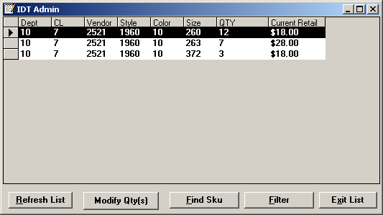

  - Database Details

select
dept,
class,
vendor,
style,
color,
size
qty,
price,
status_date (not displayed)
from idt_retick
where status = “A”
order by dept, class, vendor, style, color, size, price;

- Buttons on “IDT Admin” Window

  - The “Refresh List” Button

When the user presses the “Refresh List” button, the program should redraw the window with the currently active data. Any filters that have been applied should be removed.

  - The “Modify Qty” Button

This button is currently labeled “Modify Qty(s)”, but should be relabeled “Modify Qty”. If the user presses this button, the program should open the “Quantity Sent” window:

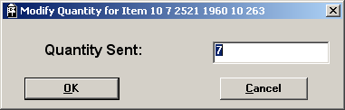

The quantity should be limited to the range 0 to 99,999.

    - If New Quantity Is Greater Than Zero

If the user keys in a value greater than zero, the program should update the quantity, then refresh the IDT Admin window, highlighting the row just updated.

update idt_retick set
qty = <new quantity>
where dept = <selected department>
and class = <selected class>
and vendor = <selected vendor>
and style = <selected style>
and color = <selected color>
and size = <selected size>
and status = “A”
and status_date = <selected status-date>;

    - If New Quantity Is Equal To Zero

A quantity of zero indicates that the program should delete the current record. The program should first confirm the request:

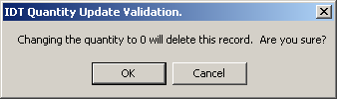

If the user cancels the request, the program should close the confirmation and the “Quantity Sent” windows.

If the user approves, the program should delete the record, then refresh the IDT Admin screen.

begin work;

delete from idt_retick
where dept = <selected department>
and class = <selected class>
and vendor = <selected vendor>
and style = <selected style>
and color = <selected color>
and size = <selected size>
and status = “A”
and status_date = <selected status-date>;

delete from idt_sku
where dept = <selected department>
and class = <selected class>
and vendor = <selected vendor>
and style = <selected style>
and color = <selected color>
and size = <selected size>
and status = “A”
and status_date = <selected status-date>;

commit work;

  - The “Find SKU” Button

This button will launch the “Find SKU” window. This allows the user to provide a SKU-level filter.

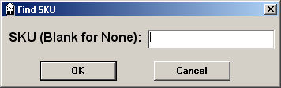

The keyed SKU must be in the range 1 <= SKU <= 9,999,999,999,999 (i.e., 13 digits). Once a SKU has been provided, the program should determine if the SKU exists in the idt_sku table.

    - Database Details

select
dept,
class,
vendor,
style,
color,
size
from idt_sku
where sku = <keyed sku>
and status = “A”
and status_date = (select max(status_date) from idt_sku
where sku = <keyed sku>
and status = “A”);

If the SKU does not exist, the program should display the error message “No Long SKU match found for SKU nnnnnnnn”.

If it does exist, the program should refresh the IDT Admin window (this time with data filtered by the requested SKU.)

    - Database Details

select
dept,
class,
vendor,
style,
color,
size
qty,
price,
status_date (not displayed)
from idt_retick
where status = “A”
and dept = <requested dept>
and class = <requested class>
and vendor = <requested vendor>
and style = <requested style>
and color = <requested color>
and size = <requested size>
order by dept, class, vendor, style, color, size, price;

  - The “Filter” Button

This allows the user to filter the list of IDT records by one or more fields.

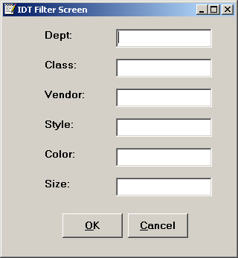

In this window, every field is optional. All of the fields should limit input to numbers from the range 0 to 99999.

If, for instance, the user fills in the fields “dept” and “style”, the resulting SQL would look like this:

    - Database Details

select
dept,
class,
vendor,
style,
color,
size
qty,
price,
status_date (not displayed)
from idt_retick
where status = “A”
and dept = <requested dept>
and style = <requested style>
order by dept, class, vendor, style, color, size, price;

  - Double-Clicking on an IDT Record

Double-clicking a detail row will cause the program display the message “Short SKU = nnnnnnnn”. If the program cannot find the associated short SKU, it should display the message “Cannot determine short SKU”.

    - Database Details

select
min(sku)
from idt_sku
and dept = <requested dept>
and class = <requested class>
and vendor = <requested vendor>
and style = <requested style>
and color = <requested color>
and size = <requested size>
and status = “A”;

